
34, VISHALA ESTATE, S.P.RING ROAD,OPP.ODHAV TO NIKOL ROAD, NIKOL, Ahmedabad, Gujarat, 382350
GST NO:-:24ARDPD2565K1ZX

info@torqpackagingsolution.com
www.torqpackagingsolution.com

Date: - 13/05/22

To.
Mr. Ajay
M/S Gokul Enterprises.
Mo:- 72270 21444

Sub: - Automatic Labeling Machine
Dear Sir,
Many thanks for your valuable inquiry of above subject. TORQ PACKAGING Solutions Is engage in making preliminary Bottle Packaging machines like bottle filling , capping , labeling, Automation, etc… in Ahmedabad, We are having dedicated team for manufacturing, customized machine development, Sales, servicing and back office.

Thanks & Regards
Parin Rathod
+91 90161 38734

Machine type | Quantity | Price
Automatic Flat And Round Bottel Sticker Labeling Machine | 1 | 5,20,000/-

Two side Automatic sticker labeling machine for flat and round bottle
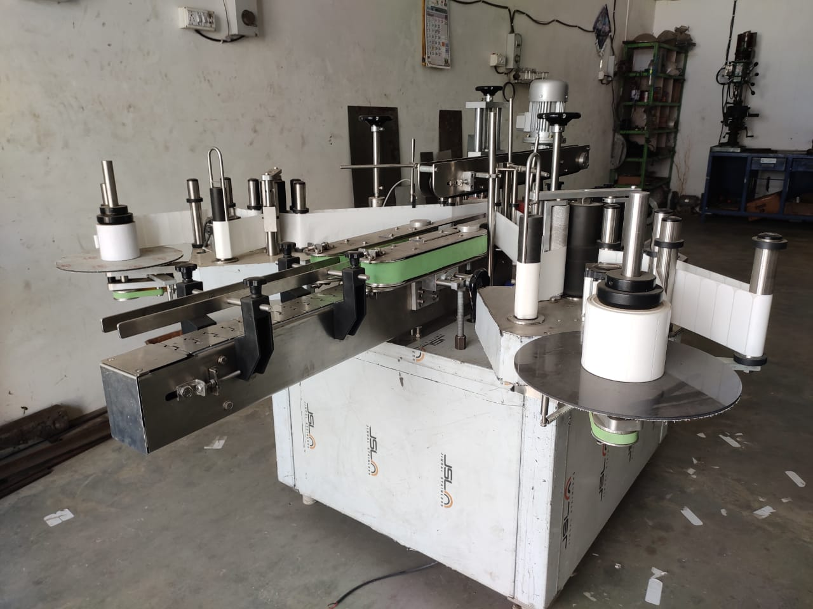

Description
The Automatic Vertical Sticker Labeling Machine is one of the most users friendly. The machine is used for full/partial labeling on different size of flat or rectangular and round containers. The automatic model is equipped with roller spacing device resulting in a simple operation with “No change parts required”.
Operation
The filled and sealed bottle is conveyed from the Conveyor and on the same conveyor one bottle separator attachment is provide to separate the bottle from continuous movement. A sensor provided to sense the product after sensing the sensor give command to operate servo motor to release label from both side when two label is stick the gap sensor give command to stop the servo or stepper during releasing of label provision of brush to press the label & remove the air between label & bottle after completion of the cycle one operation of labeling is finish & conveyor bring the bottle for next operation..
Technical Specifications
Output/Hour* |  |  |  | 3000 to 4200 (for flat bottle)  3600 to 4800 (for round bottle)
Direction of Movement |  |  |  | Left to Right
Controller |  |  |  | PLC based control
Power Consumption | Conveyor motor |  |  | 0.25 HP / 415 V / 50 HZ
 | Pressing device motor |  |  | 0.25 HP / 415 V / 50 HZ
 | Servo motor |  |  | 400W(each side)
For flat container |  |  |  | Bottle movement through top drive
For round container |  |  |  | Bottle movement through side drive
Height of Conveyor |  |  |  | 850 mm to 900 mm Adjustable
Machine Dimensions** |  |  |  | 2100 mm (L) x2100 mm (W) x 1500 (H) Approx.
Case Dimensions |  |  |  | 2850 mm (L) x 2150 mm (W) x 1550 (H) Approx.
Net Weight |  |  |  | 500 Kgs. Approx.
Gross Weight |  |  |  | 650 kgs Approx.
Input Specification
Label Specifications |  | Length** |  | 240mm Max
 |  | Height |  | 150mm
 |  | Roll Diameter |  | Max 300 mm & ID 75 mm
 |  | Space between two label |  | Min. 3 mm anti clock wise
* Depends on Container size, fill size, Neck diameter of container, and nature of liquid etc.
** We can supply as per customer requirements.
Salient Features
- High Production Speeds.
- SS steel structure cladded with stainless steel 304 sheet to meet GMP norms.
- Servo PLC Based operation
- Accurate label placement.
- No change parts requirements.
- Very less down time for change over.
- Suitable for Glass, Plastic, Pet, Tin, Corrugated containers.
Utility Requirement
Electrical supply |  |  | 1 Phase + Neutral + Earthing
Electrical load |  |  | 2 KW

- Terms & Conditions

1 | PRICE | The prices mentioned are ex our Ahmadabad works
2 | TAXES & DUTIES | 18% extra
3 | TERMS OF PAYMENT | We agreed to have 50% advance and 50 % before Dispatch.
4 | DELIVERY  PERIOD | Within 3-4 Weeks from the date of receipt of technically & commercially clear order along with advance payment or receipt of approval for input dimensions, whichever is later
5 | INSURANCE | Transit Insurance against Theft, Pilferage, Breakage, Etc. will be arranged at extra cost at your explicit instruction, otherwise it will be assumed that goods are to be sent at your risk. Cost of such insurance will be as actual to be borne by the consignee.
6 | TRANSPORT | Transportation of the machine from our factory has to be arranged by you. We will arrange for loading of the equipment at our factory. However unloading at site has to be arranged by you. Our responsibility ceases once the goods leave our factory and are handed over to carrier. We do not undertake any liability for damage/ loss in transit whatsoever, whether the goods are insured or not. In case of any damage / accident during transit, the client has to directly deal with the insurance company without holding any payments, irrespective of the insurance arranged by Consigner or Consignee.
7 | INSPECTION | We offer inspection of the machine at our factory, by your technically competent representative, prior to dispatch. This person should be present on our factory during packing and loading of the machine. In case you are not deputing anyone for pre dispatch inspection, then we will not entertain any dispute arising out of short supply, quality, workmanship, functionality, operating parameter, etc. once the machine is dispatched.
8 | FACTORY  TRAINING | We will impart training to your operating staff in our factory before the machine is dispatched, at no additional cost. However, his lodging-boarding and local traveling expenses will have to be borne by you. This person should be technically competent to uncrate and assemble the machine at site before the arrival of our commissioning engineers. He must ensure that ground work necessary at site is competed in all respects before machine. Commissioning, He must be competent enough to be able to run the machine and carry out routine maintenance, once the machine is handed over after commissioning
9 | INSTALLATION | The machine has to be uncarted and placed in working position by you at site. You have to carry out all the external powers and air compressor at site. The machine must be available in the fully assembled condition when our commissioning engineer arrives at site.
10 | COMMISSIONING | For supervising and commissioning of the machine we will depute one of our engineers on chargeable bases. Customer will have to send a prior intimation of readiness of electrical and utility connections along with required materials.  Rs. 2,000/- per man day will be charged. Customer will reimburse to and for 1st class fare from  Ahmedabad to the destination, lodging and boarding expenses and other local expenses for the period of commissioning.
11 | SPECIFICATION | In line with our policy of continual improvements, we reserve The right to modify the design and change the specifications and make of any material, if in our opinion such modification leads to an improvement in the performance of the machine. Therefore specification, illustrations, dimensions, offers, drawings or photographs are not binding in detail.
12 | WARRANTY | Our goods carry a warranty of one-year trouble free operation from the date of dispatch. The warranty is only against manufacturing defect. It does not cover any electrical, electronic or bought out components.  Components getting normal wear and tear would be replaced at your cost.
13 | NOTE | Customer have to provide samples of bottles, caps, labels etc. along with the purchase order otherwise machine will be made as per our standard specifications, wherein we will take trial with water, caps, bottle, label etc available with us, which will be acceptable to you.
14 | CANCELLATON  OF ORDER | Order once placed, cannot be cancelled under any circumstances. In case of orders being cancelled, then the entire amount of advance payment will stand forfeited.
15 | OFFER VALIDITY | This offer remains valid for the period of 30 days. Any extension thereafter will be subject to our written confirmation only.
16 | JURISDICTION | No legal proceedings shall be taken to enforce claims and no suit arising out of any contracts shall be instituted except in a court of competent jurisdiction located within Ahmedabad, Gujarat.

